**📄 DNS Mini Project Documentation Template**

**🔹** 1. Title: Analyzing a DNS AAAA Query to Google STUN Server

🔹 2. Objective: To analyze DNS traffic using Wireshark by capturing and interpreting an AAAA query made to stun4.1.google.com.

🔹 3. Summary: Using Wireshark, I captured a DNS query from my system requesting the IPv6 address of stun4.1.google.com. The DNS response returned the IPv6 address: 2001:4860:4864:5:8000::1.

### 🔹 4. Key Fields (Table):

|  |  |
| --- | --- |
| Field | Value |
| Queried Domain | stun4.1.google.com |
| Query Type | AAAA (28) |
| Response Address | 2001:4860:4864:5:8000::1 |
| Protocol | DNS over UDP |
| Destination Port | 53 |

### 🔹5. Screenshot 1 – DNS Query Packet:

This screenshot shows the DNS **query packet** sent from my system to a DNS server.  
Under the expanded **Domain Name System (query)** section, we can see the queried domain:  
stun4.1.google.com and the query type: AAAA, which requests an IPv6 address.

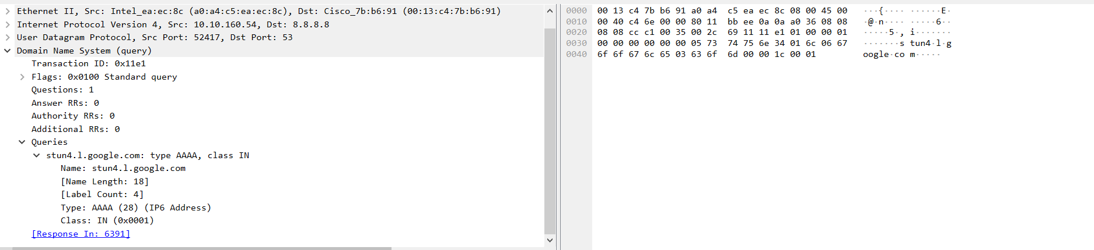

### 🔹 Screenshot 2 – DNS Response Packet:

This screenshot shows the **response** from the DNS server.  
Under the **Domain Name System (response)** section, the server returns the IPv6 address:  
2001:4860:4864:5:8000::1 for stun4.1.google.com.

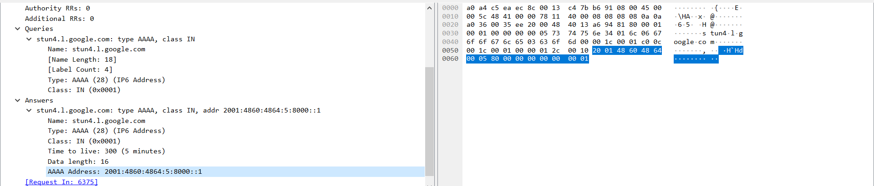

## 🔚 Conclusion:

This project demonstrated how to use Wireshark to capture and analyze a real DNS IPv6 (AAAA) query and its corresponding response.